**Han Academy Web**

**Software Requirements Document**

|  |  |  |  |  |  |  |
| --- | --- | --- | --- | --- | --- | --- |
| Software Name: | Han Academy Web | | | Version #: | | 5 |
| Author: | Amanda Cobb | | | | | |
| Date: | October 12, 2015 | | | | | |
| Revision History: | | | What was done… | | Date: | |
| Initial write up | | Listing the requirements, purpose, stakeholders, meeting notes, | | | September 21, 2015 | |
| Revision 1 | | Revising the requirements, purpose, stakeholders, Interface Requirements | | | September 28, 2015 | |
| Revision 2 | | Interface Requirements, pictures | | | September 30, 2015 | |
| Revision 3 | | Index, Go over everything | | | October 5, 2015 | |
| Revision 4 | | Interface Requirements | | | October 12, 2015 | |

1.0 Introduction 1

1.1 Purpose: 1

1.2 Stakeholder: 1

1.3 Social and Economic Benifits: 1

2.0 Overall Description 1

2.1 Scope of the Software enhancement 1

2.2 Available Sources 1

3.0 Functional Requirements 2

3.1 Administrative Users …………………………………………………………………………………...2

3.2 Teacher User ……………………………………………………………………………………………2

3.3 Student User …………………………………………………………………………………………….3

3.4 Parent User………………………………………………………………………………………………3

4.0 Interface Requirements 4

4.1 Dashboard and Homepage 4

4.2 Adding a new Course 5

4.3 Turning Courses Invisiable 6

4.4 Adding a Resource or Activity 8

4.4.1 Adding a Resource 9

4.4.2 Adding a URL…………………………………………………………………………………..10

4.4.3 Adding an Assignment.………..………………………………………………………………..11

4.4.4 Adding a Quizzes……………………………………………………………………………….12

4.4.5 Adding Chat…....………………………………………………………………………………..16

5.0 Data Management 18

6.0 Non-Functional / Operational Requirements 18

6.1 Security, Availability, Reliability, Recoverability and Business Continuity 18

6.2 Technical Reviews, Audits, and Walk-Through 18

7.0 Appendices 20

7.1 Requirment Engineering Methodology 20

7.2 Meeting Minutes 20

### Introduction

#### Purpose:

This application is to improve an existing Moodle, to better serve parent, student, and teacher. It will make all information posted accesable from any PC with internet connection. The application will mainly be focusing on K-12 grades. The application will enable students to learn better and teachers be more efficient. This application also allows comuncation to occur between teacher and parent or teacher and student.

Moodle is used to help design their own themes and make it special for Han Acadmey. This way their no useless iteam visable that another organization might have used.

#### Stakeholder:

There are 3 sets of stakeholders for this product: Students, Teachers and Administrators. The main stakeholder affected by the changes described in this document are the teachers.

#### Social and Economic Benifits:

The current teachers interface and functions are very basic and not user friendly. These changes will make the teacher’s interface more robust and easier to use.

### Overall Description

#### Scope of the Software enhancement

These changes will improve the ease of use and functionality available to instructors.

#### Available Sources

* The GSU course web application is a web application that is available from any PC that has internet access.
* The software will be deployed to the Cloud (via Google server) and the new version will be accessed by the teachers the next time they log in.
* There will be no additional hardware or set ups needed since the basic set up is already in place with the current GSU course web application.
* The current GSU course web application is written in C sharp. All extensions of this application should be written in the same language for maintainability.
* Required Development Tools
* Security would stay consistent with the security already in place for this application.

### Functional Requirements

The proposed changes will add multiple new screens that will provide the instructor with more functionality. After these changes are released, the instructor will be able to:

#### Administrative User

1. Must be dynamic.
2. On the homepage doesn’t want the contact info for the teacher but for the school itself.
3. Must be able to have some news (Enrollment time, Conferences, Stay heathy).
4. The homepage should be about the school and Click here for enrolling.
5. Clicking on the course, I want it to show a brief description of the course.
   1. When clicked you can either enroll
   2. Or talk to somebody at the school.
6. After they enroll, they must give detailed information (contact).
   1. If there is more than 30 enrolled already, then create a waiting list for the extra enrolling students.
7. Notifications for grades submitted or graded.
8. A way to tell if a java code is compiled correctly? Can you submit the source code then it some can compile give the output back? (Like ‘Practice It’).
9. Limit the maximum upload size.
10. Turn courses invisible (hide) when courses are not available for the semester.
11. When a user views a video make sure the full screen video works properly.

#### Teacher User

1. The teacher must be able to communicate with the students.
2. The teacher must be able to post the content.
3. A Discussion Board for the students to communicate with each other and the teacher.
4. Teachers should be able to add new units to the course.
5. Teachers should be able to Manage existing Units
   1. Delete existing Units
   2. Edit existing Units
6. Teachers should be able to manage documents in units.
   1. Add documents to units.
   2. Delete existing documents from units
7. Mange Internet Site Hyperlinks
   1. Add new Internet Site Hyper Link
   2. Edit existing Internet Site Hyper Links
   3. Delete existing Internet Site Hyper Links
8. Manage Quizzes
   1. Create Quizzes
   2. Edit Quizzes
   3. Delete Quizzes

#### Student User

1. The student must be able to view the content posted by the teacher.
2. Student must be able to view the content posted by the teacher.
3. A Discussion Board for the students to communicate with each other and the teacher.

#### Parent User

1. The parents can see the class list. They can click on the course to
   1. Enroll in the course,
   2. Or give contact info.
2. The parents must be able to view the students work.
3. Archive past courses that were taken by the student.

### Interface Requirements

#### Dashboard and Homepage

The following screen should be similar to what the user will see after logging-in also known as the Dashboard.

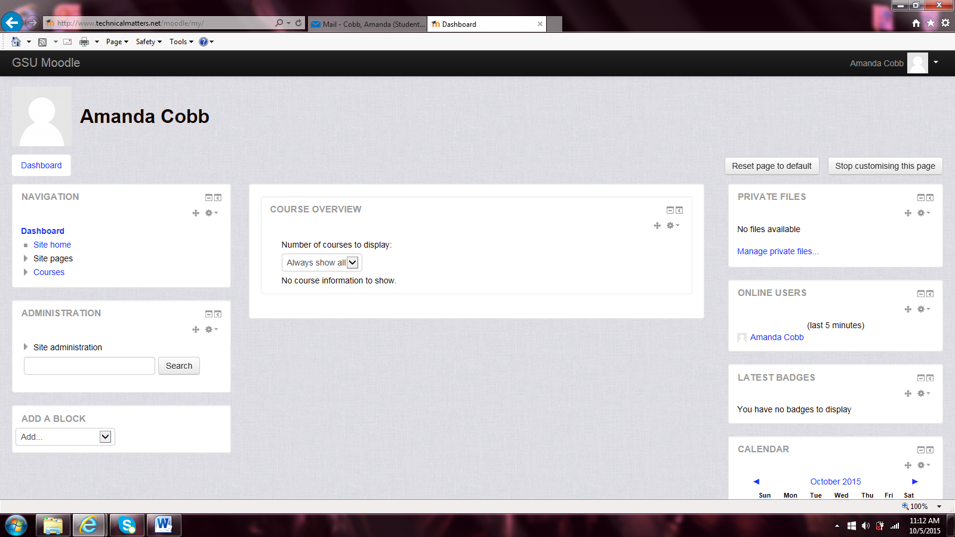

The actual site home page will look something like the picture below.

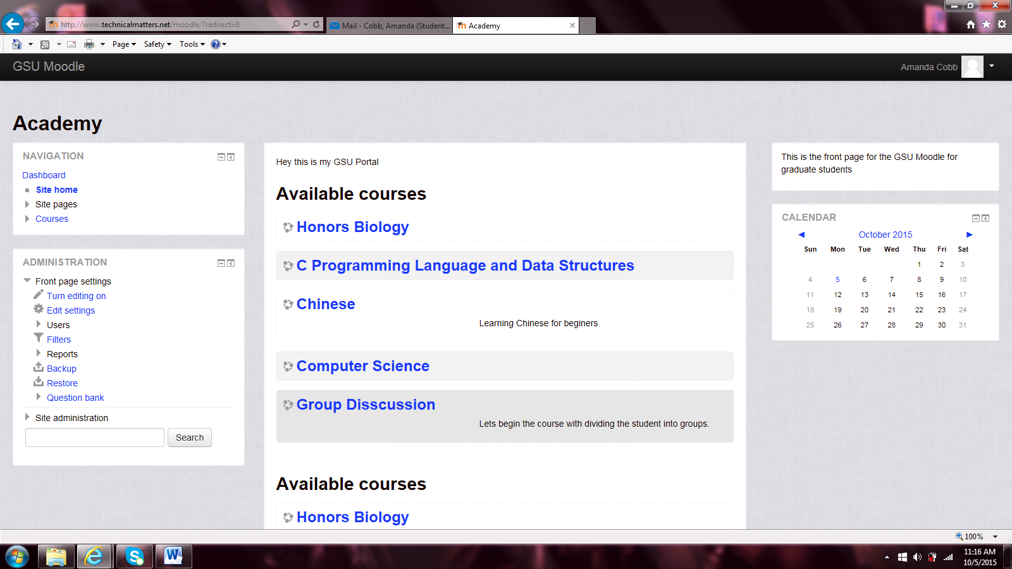

This screen only shows the courses available, course categories, and courses search box.

#### Adding a new Course

To add a new Course the user should go to the courses page and the picture below should be the screen you get or something similar.

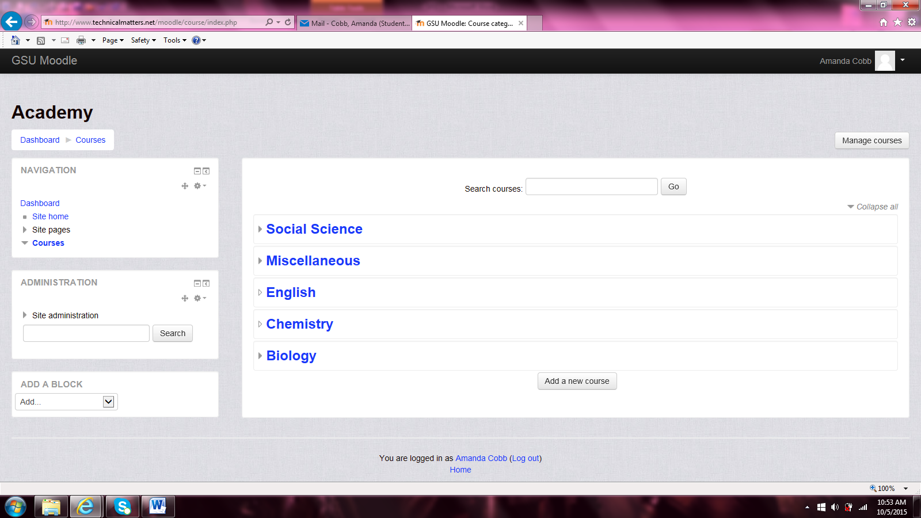

Then the user needs to click then add a new course button to get the screen below or something similar.

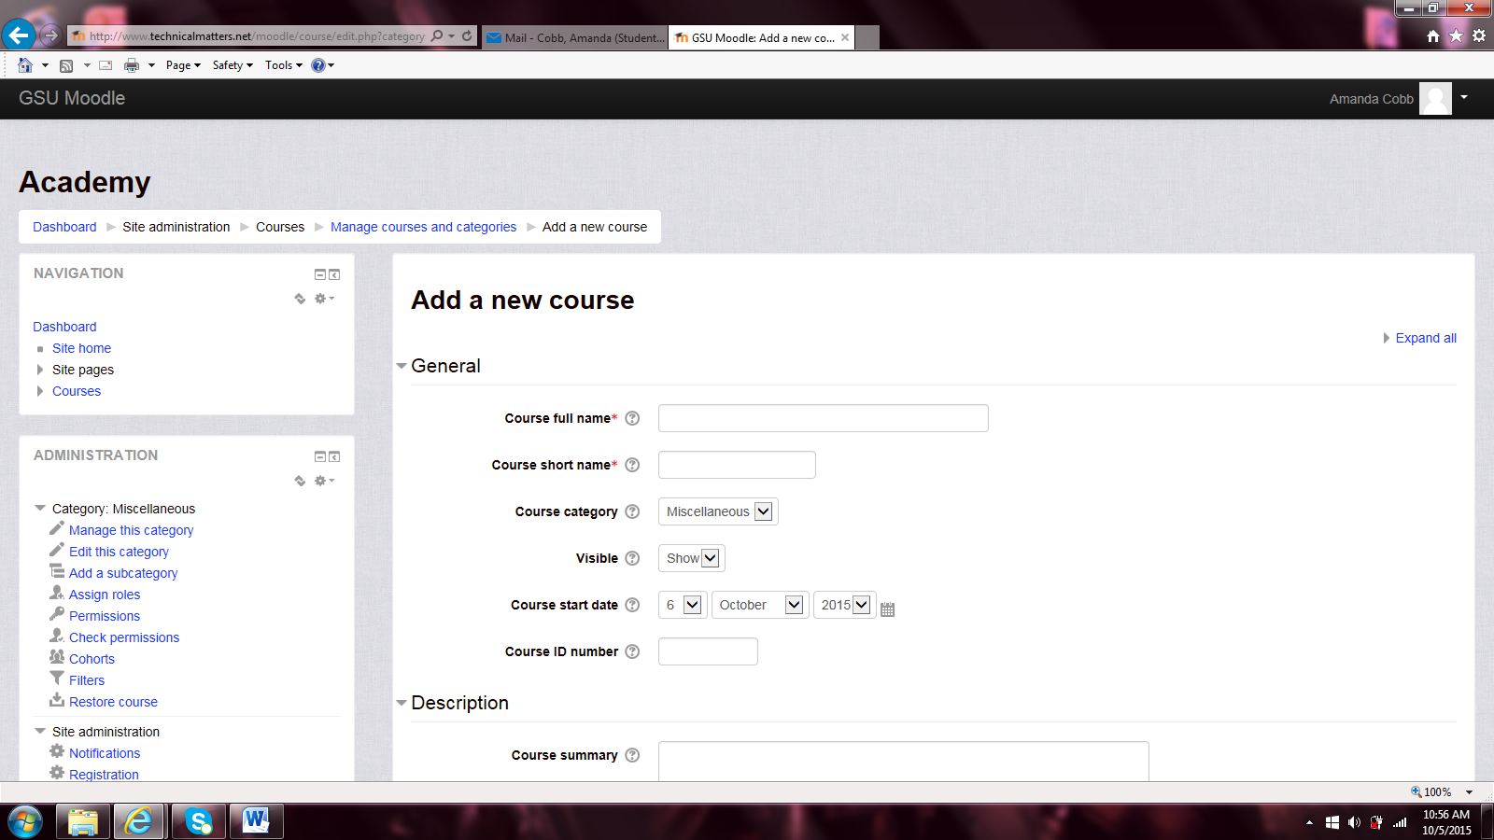

Then just add in the new course info then click save and display. If you un-collapse all the courses the user will see the new course, Chinese.

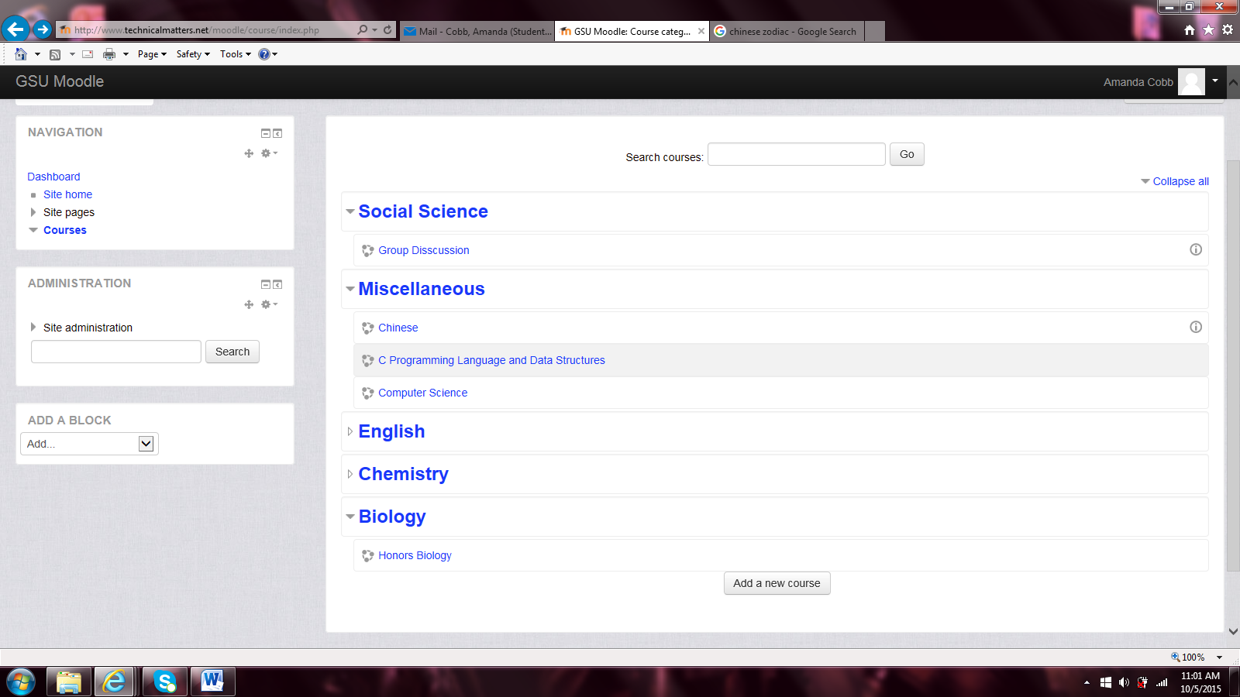

#### Turning Courses Invisiable

If the user wants a course to not show all the time such as when the course is not available for that semester then turning it invisible is the way to go. The user needs to be back at the courses page like the picture above. Then click the ‘manage courses’ button. The screen should look similar to the picture below.

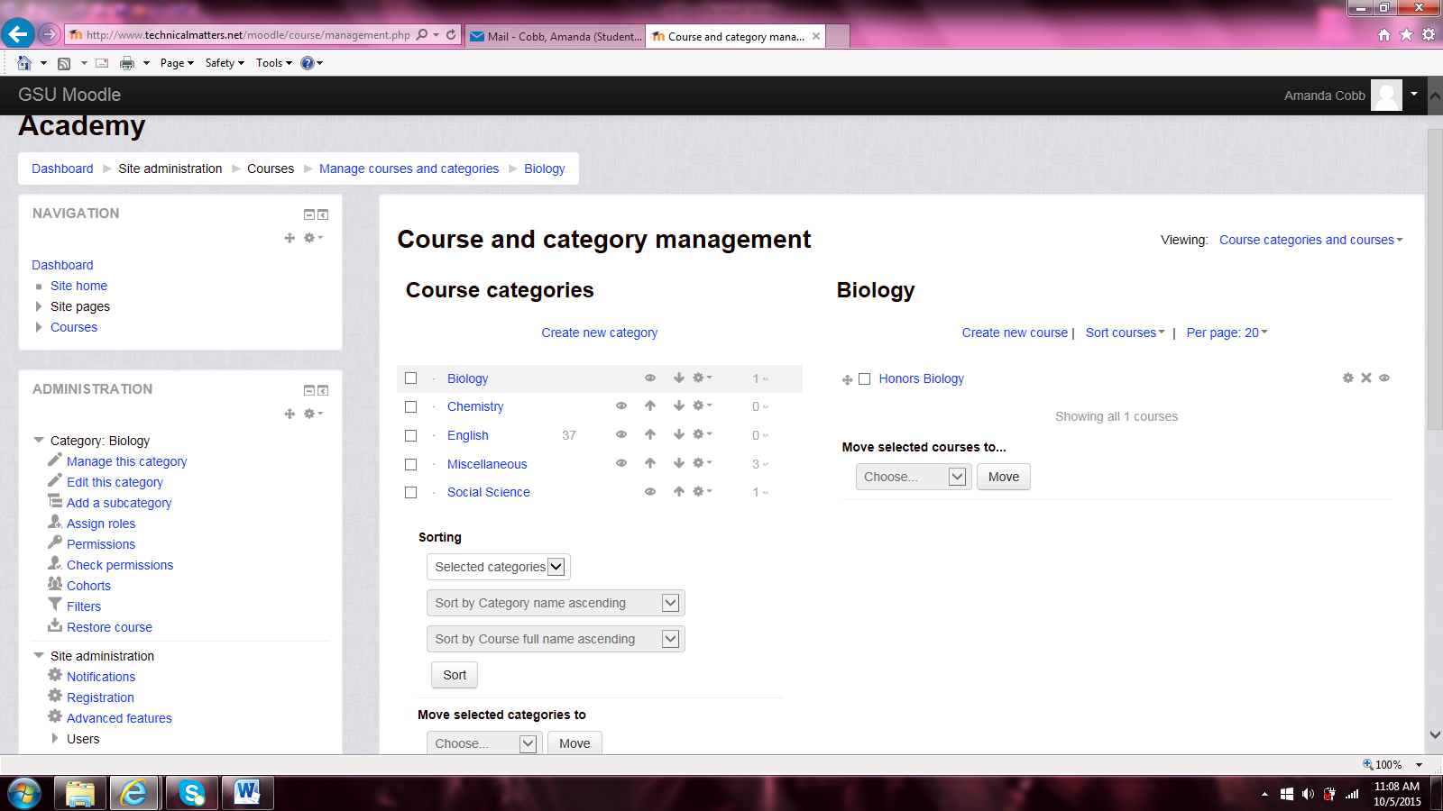

Choose the course or category that you want invisible then click the icon that looks like an eye. In the figure below is what the course would look like after being hidden.

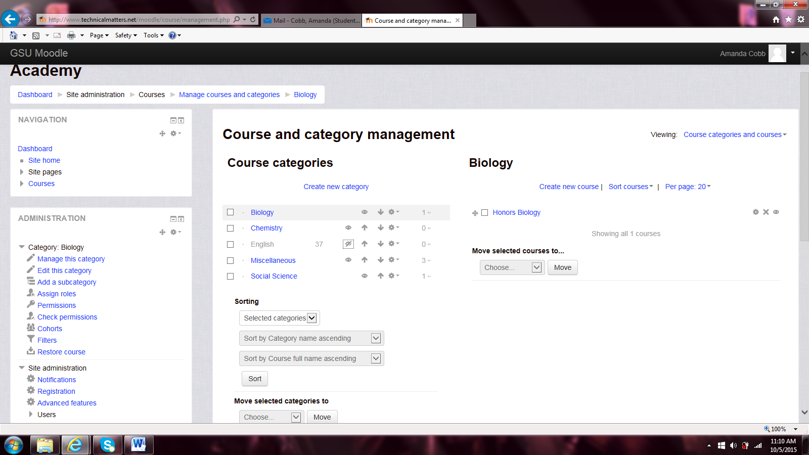

If the user goes back to the courses page it should look similar to the screen below.

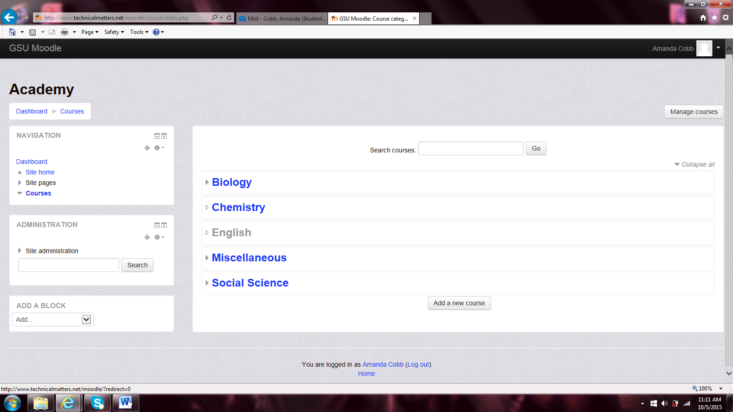

#### Java Code

When a student enters java code the teacher will want the site to actually check the code to see if its correct or not. Three things can happen when they enter code to be checked, below is the different cases.

###### Test Case 1

When a student enters their code in the textbox and the code is correct.

**Code:**

Public class Hello {

Public Static void main (String[] args) {

System.out.print(“Hello”);

}

}

Press Submit Button

|  |  |  |
| --- | --- | --- |
| Expected | Your Output | Pass/Fail |
| Hello | Hello | Pass |

###### Test Case 2

When a student enter their code but there is a Syntax Error.

**Code:**

Public class Hello {

Public Static void main (String[] args) {

System.out.print(“Hello”)

}

}

Press Submit Button

|  |  |  |
| --- | --- | --- |
| Expected | Your Output | Pass/Fail |
| Hello | Syntax Error | Fail |

###### Test Case 3

When a student enters their code but it something is wrong with it.

**Code:**

Public class Hello {

Public Static void main (String[] args) {

System.out.print(“Helo”);

}

}

Press Submit Button

|  |  |  |
| --- | --- | --- |
| Expected | Your Output | Pass/Fail |
| Hello | Helo | Fail |

#### Adding a resources or activity

To add an assignment to the course the teacher user needs to click on the course. Then the screen below appears.

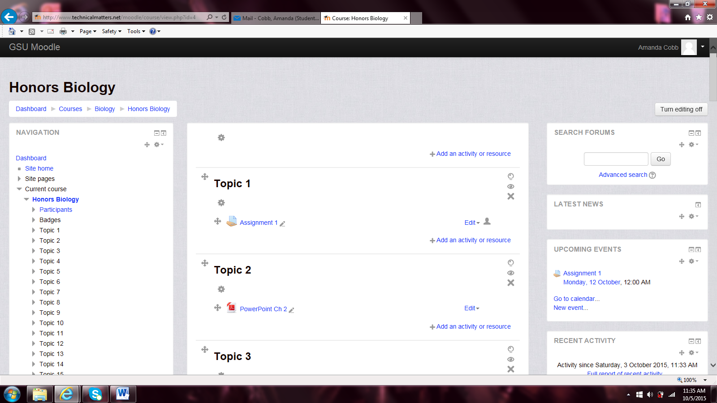

Go to the topic you want to add an assignment to. Then click the link that says ‘Add an activity or resource’.

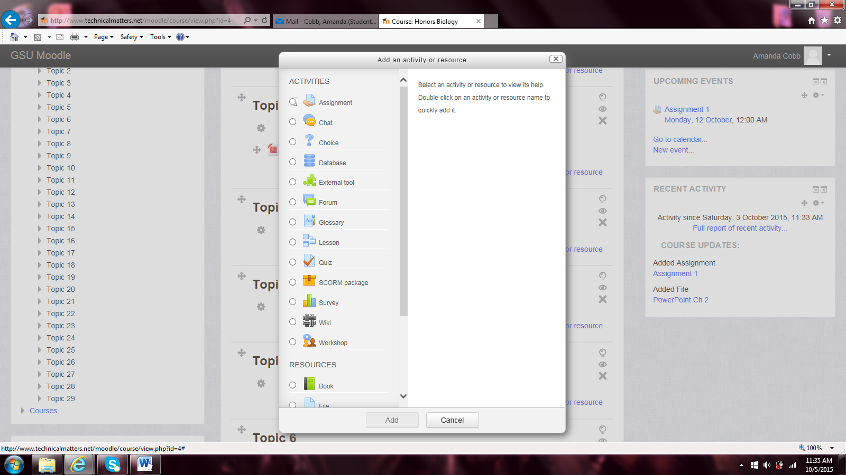

###### Adding a Resource

To add a resource such as a PowerPoint the user needs to click the File link under the Resource section. Then click the add button. The picture below is the next screen that will appear.

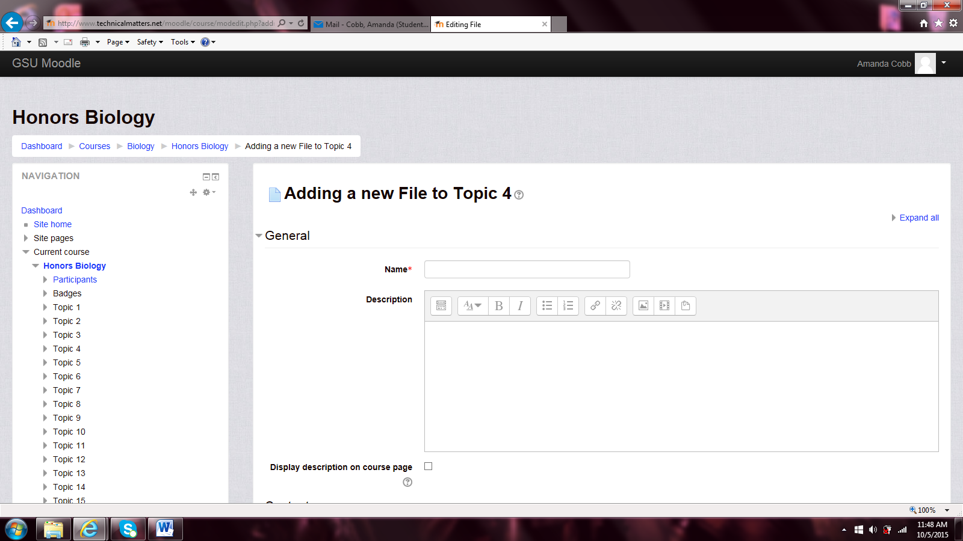

Enter the details and the file by scrolling down to the content section. To select the file click within the box with arrow or drag and drop in the box. The picture below is if click within the box.

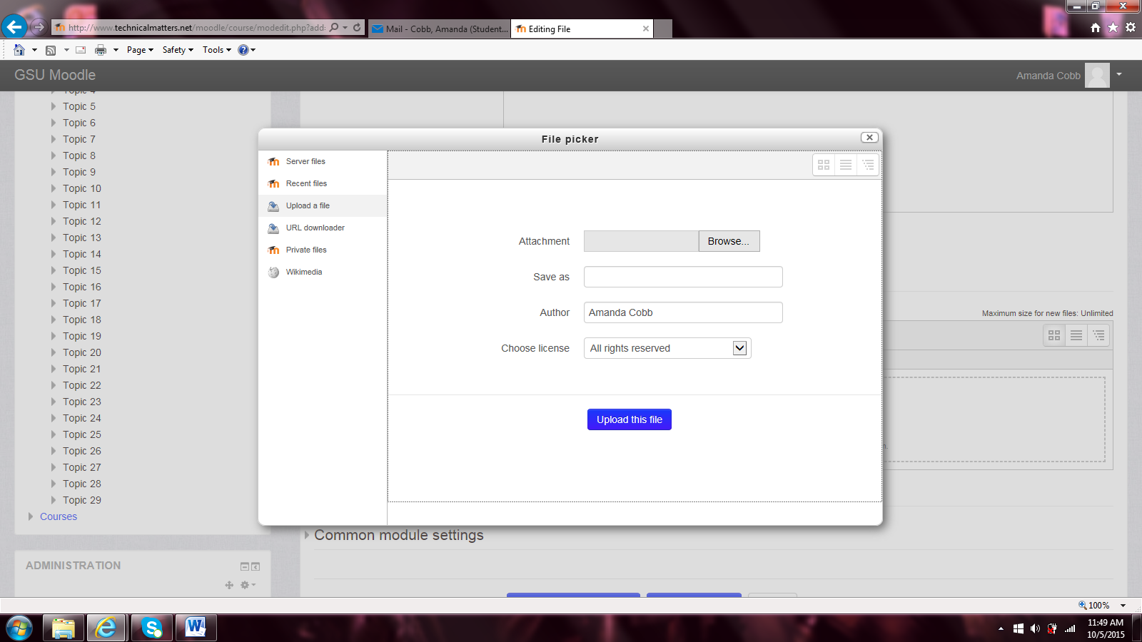

Add the file that is needed using the Browse button and then click the ‘upload this file’ button. Then scroll to the bottom of the screen and click the ‘save and display’ button. The picture below is the screen that will show up afterwards.

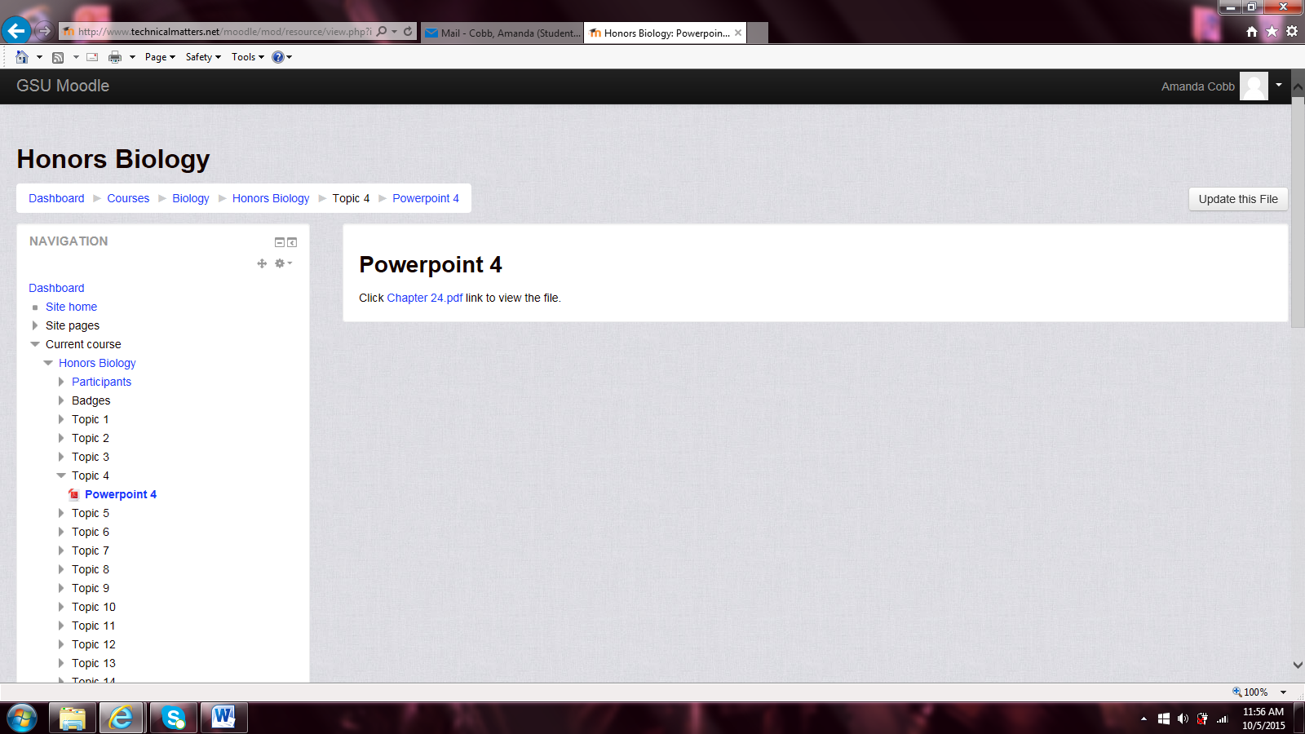

* + 1. **Adding a URL**

To add a URL, click the URL link under the Resource Section and click the ‘Add’ button. The picture below is the screen that will appear.

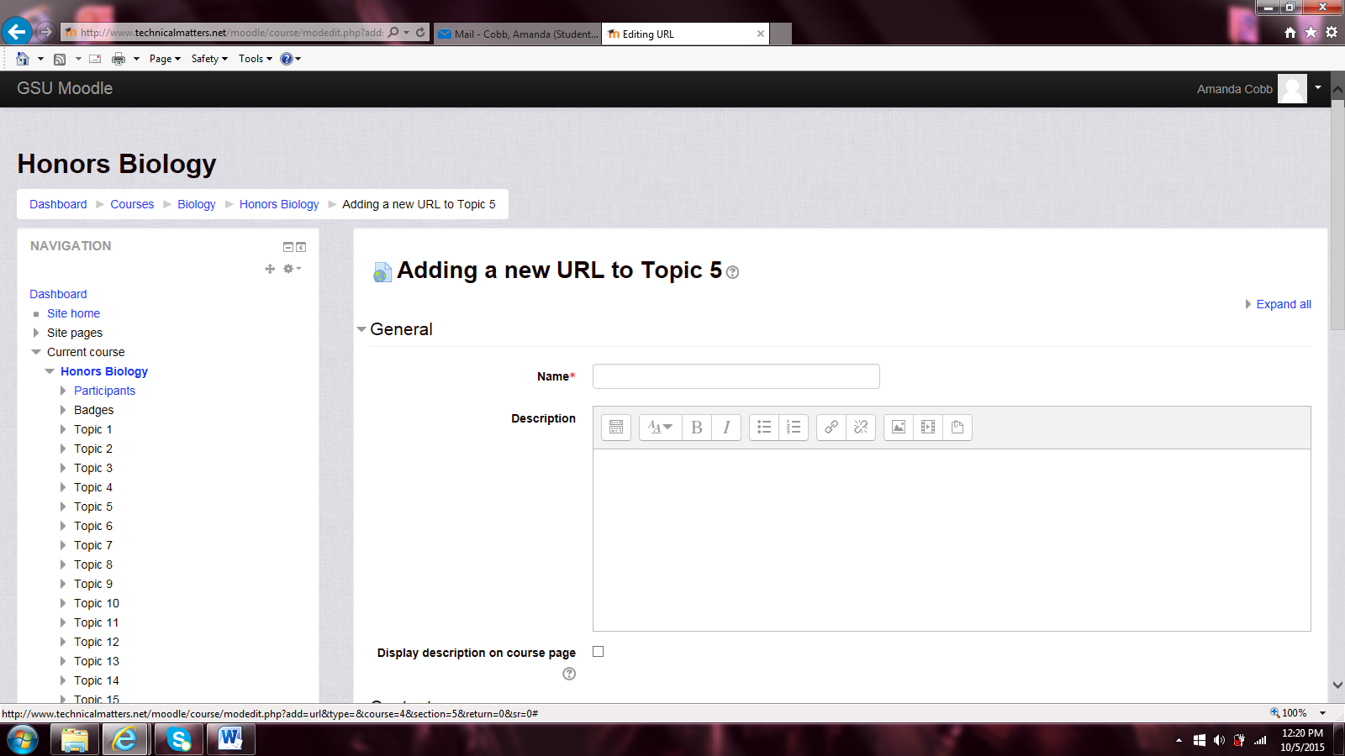

Enter all the details that you as the teacher user would like. The URL can be copied and pasted in the textbox or click the ‘Choose Link’ button. The screen below is what will appear after the ‘save and display’ button is clicked.

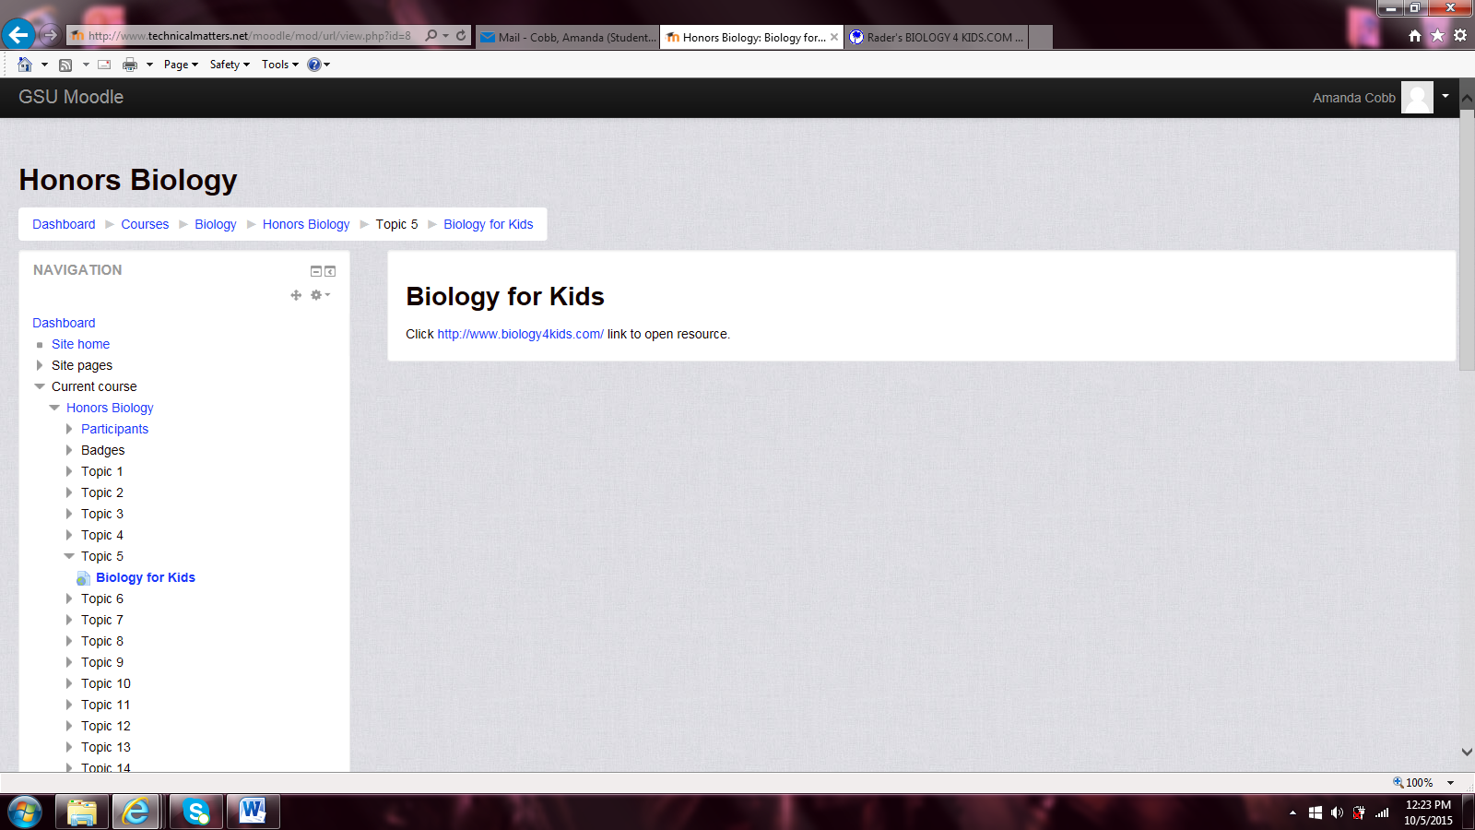

* + 1. **Adding an Assignment**

To add an assignment, click the assignment link. Then click the add button. The picture below should be the screen the user gets.

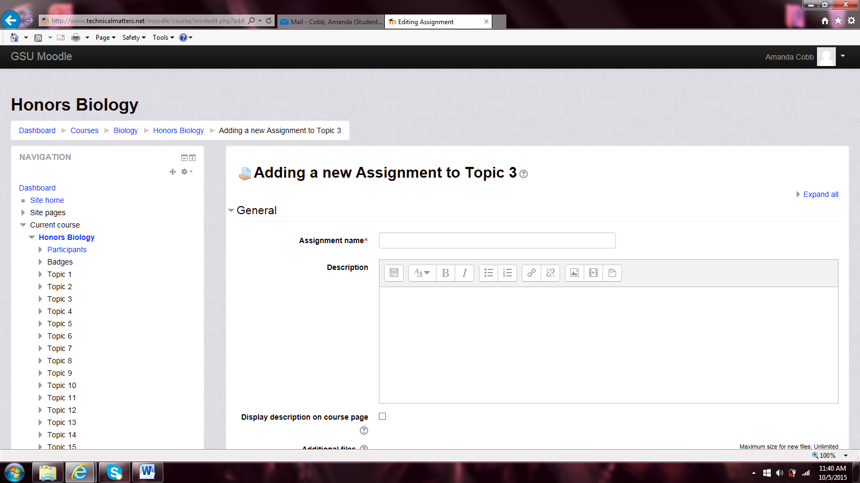

Enter all the detail you as the user would like, then press the ‘save and display’ button. The screen you come to is the submissions for the assignment and the number participants. The picture below shows the screen.

. 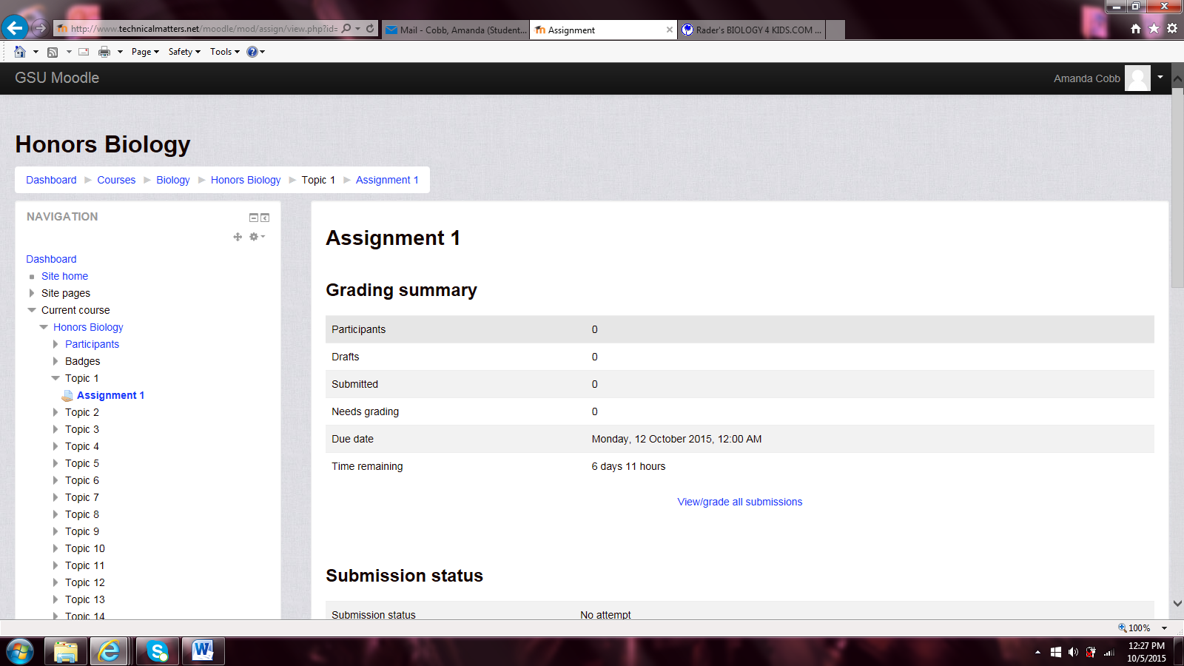

* + 1. **Adding Quizzes**

To add a Quiz, click the Quiz link and then the ‘Add’ button. The picture below shows the screen that will appear.

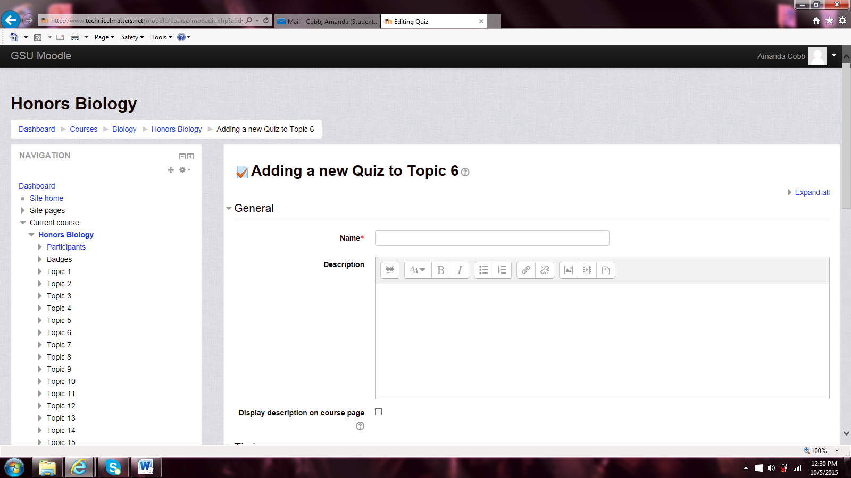

Enter the detail you as the user would like, such as the name of the Quiz. The picture below is the screen that will appear.

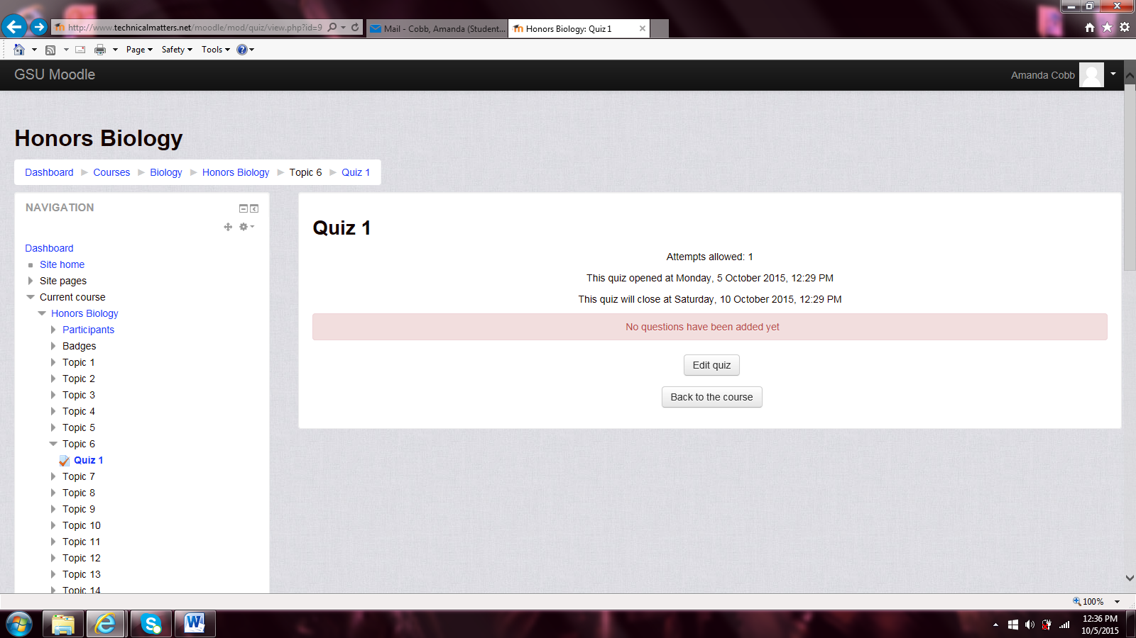

To edit the quiz, click the button ‘Edit Quiz’. The picture below is the screen that will appear.

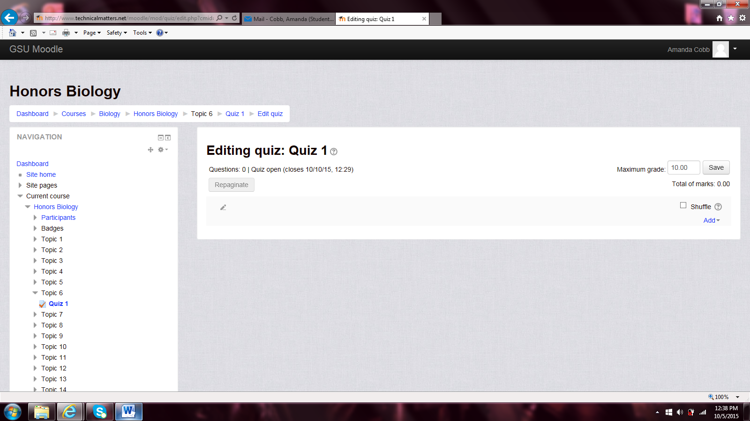

Click the ‘Add’ link to get choice between ‘new question’, ‘from the question bank’, and ‘random question’. Click the one you as the teacher user would like. The picture below is what appears when the ‘new question’ link is clicked.

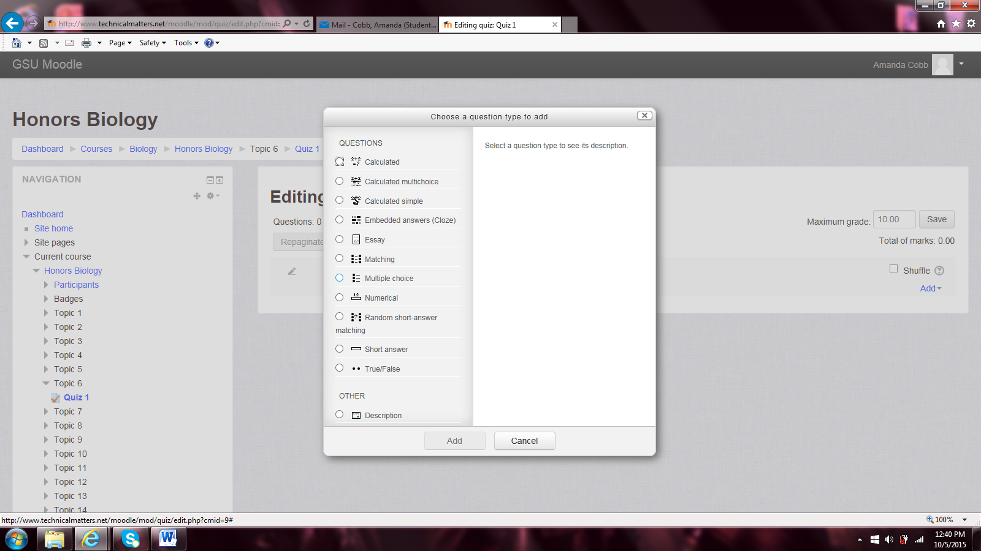

Click the type question it will be, such as ‘matching’, ‘multiple choice’, ‘True/False’, etc. then click the ‘add’ button. The ‘multiple choice’ link was chosen for the picture below to appear.

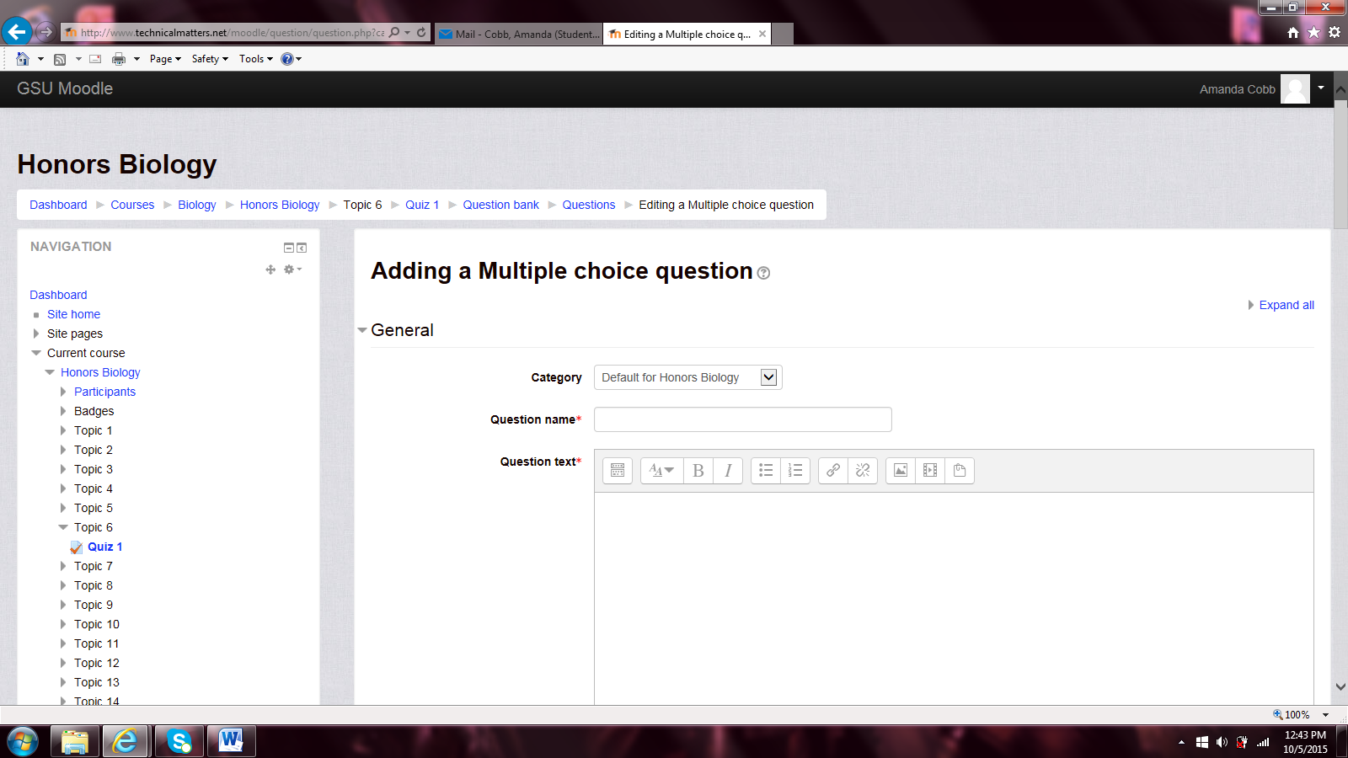

Enter the question and the different answers. Make sure the correct answer the student can get the credit for selecting it. The picture below is the screen that will show question has been added.

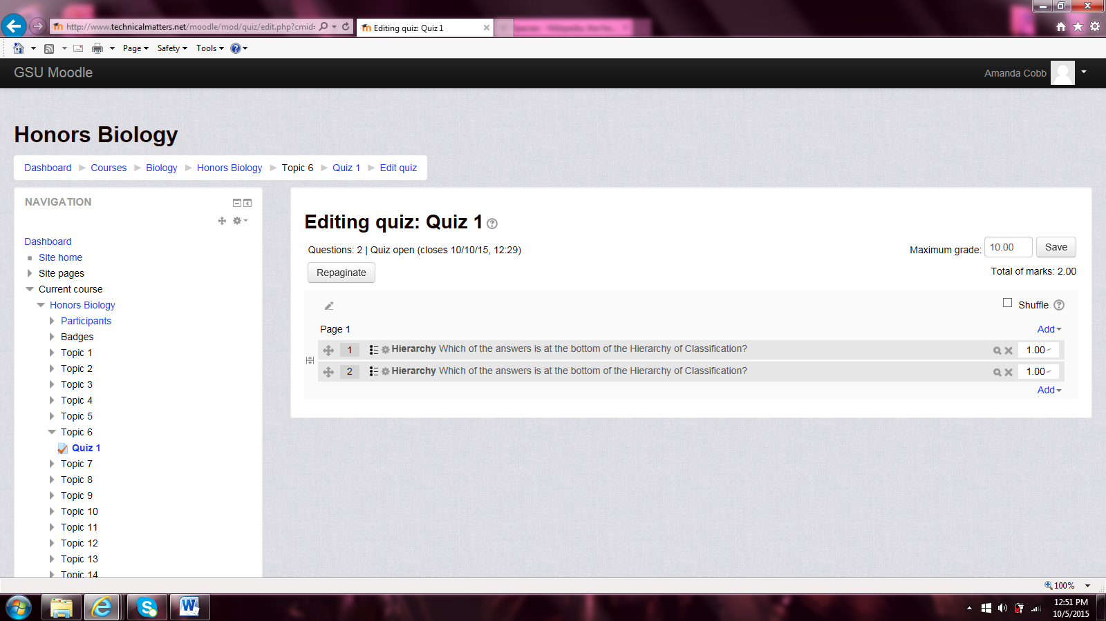

To delete a question click the X and picture below is what the screen will look like.

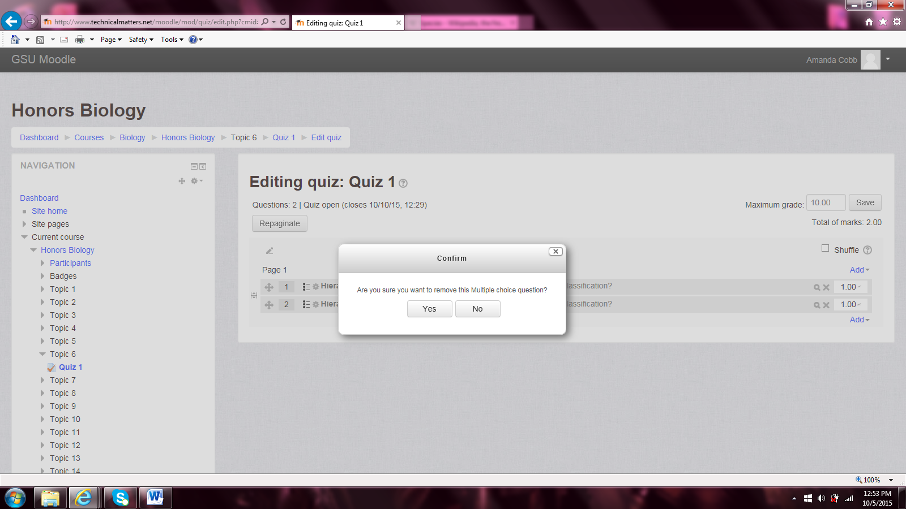

Click ‘yes’ and the screen will look similar to the picture below with the missing question.

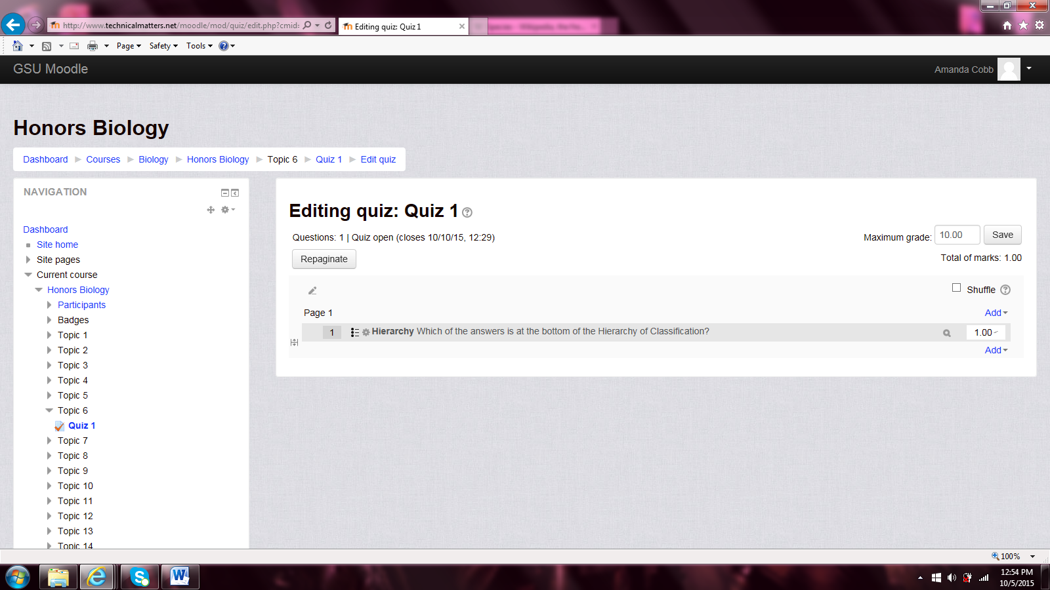

###### Adding Chat

Chat is a lot like a discussion board for the users. Click the Chat link then the ‘Add’ button.

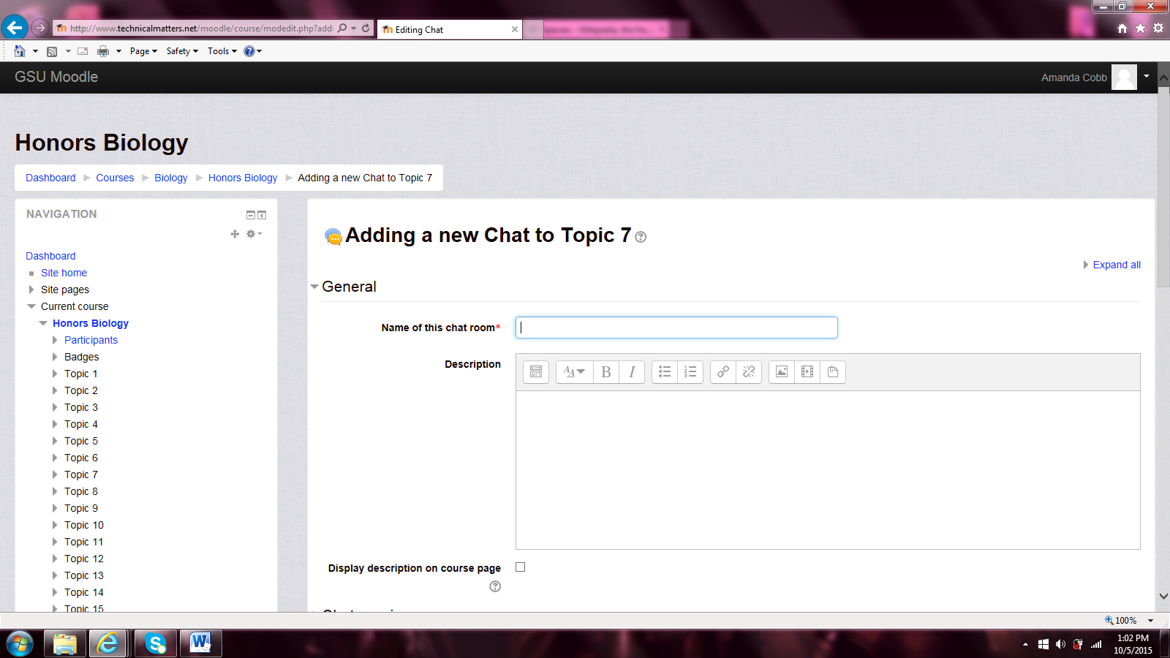

Enter the details you as teacher would like. Such as the name of the chatroom or who view the past messages. The picture below shows the screen that will appear after the ‘save and display’ button is clicked.

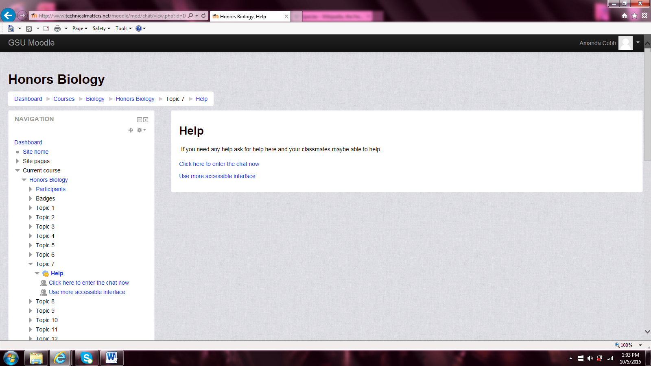

If the ‘Click here to enter the chat now’ link is clicked the picture below shows the screen.

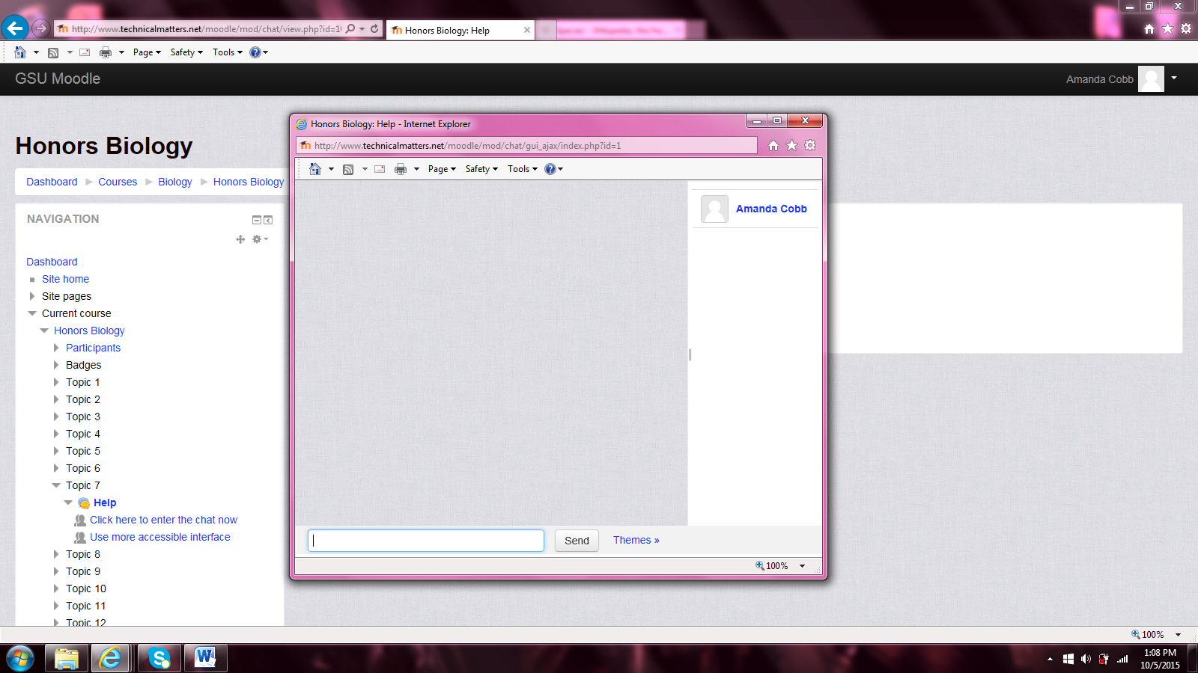

### Data Management

All courses, units, items in the units will be stored in a database. They will remain in the database for 5 years. After which time they will be backed up and stored in a warehouse for record keeping.

### Non-Functional / Operational Requirements

* No guests can log-in.
* The number of students.

#### Security, Availability, Reliability, Recoverability and Business Continuity

Describe the attributes of each of the topics listed

* Security - There is already security in place for this application. All changes made here are to conform to those same standards.
* Availability - The system should be available 24/7. If maintenance is needed, it should be done on Saturday mornings from 1:00am - 4:00am.
* Reliability -The system needs to be reliable for the students and the instructors to complete their work in a timely fashion.
* Recoverability - If the web application fails, a user can re-login and all data will reappear as it is being stored on the database.

#### Technical Reviews, Audits, and Walk-Through

After each screen is complete, there will be a review of the screen by the developers’ peers. Once a function is complete it will be shown to the user and after the user acceptance testing, it will be completed.

|  |  |
| --- | --- |
| Target Date | Milestone |
| 3/13/16 | 1. Complete GUI interface to add new Units/peer review |
| 3/14/16 | Complete QA testing of new GUI interface #1 |
| 3/15/16 | Complete User Acceptance testing of new GUI interface #1 |
| 3/20/16 | 2. Complete GUI interface and functionality to allow units to be copied from previous class./peer review |
| 3/21/16 | Complete QA testing of new GUI interface #2 |
| 3/22/16 | Complete User Acceptance testing of new GUI interface #2 |
| 4/3/16 | 3. Complete GUI interface to manage existing units/peer review |
| 4/4/16 | Complete QA testing of new GUI interface #3 |
| 4/5/16 | Complete User Acceptance testing of new GUI interface #3 |
| 4/10/16 | 4.Complete GUI interface to manage documents in units/peer review |
| 4/11/16 | Complete QA testing of new GUI interface #4 |
| 4/12/16 | Complete User Acceptance testing of new GUI interface #4 |
| 4/17/16 | 5. Complete GUI interface to manage Internet Site Hyperlinks/peer review |
| 4/18/16 | Complete QA testing of new GUI interface #5 |
| 4/19/16 | Complete User Acceptance testing of new GUI interface #5 |
| 4/24/16 | 6. Complete GUI interface to manage Quizzes/peer review |
| 4/25/16 | Complete QA testing of new GUI interface #6 |
| 4/26/16 | Complete User Acceptance testing of new GUI interface #6 |
| 5/7/16 | Complete INTEGRATION TESTING |
| 5/8/16 | Release |

### Appendices

#### Requirment Engineering Methodology

We will be using an Agile Methodology to complete this project.

#### Meeting Minutes

**Meeting #1**

Meeting Date: 8/31//15

Meeting Place: GSU

Meeting Attendees: Instructor-Clare Tang & Students

Meeting Minutes: Introduction to Moodle and SRD

Q: What’s the Purpose?

A: To better serve parent, student, and teacher. To help the student learn better. To help the teacher be efficient.

Customer Meeting

Using Moodle. Non-profit organization.

Client: Focus on K-12 grades. I heard that it’s a great, open source. My colleague uses it, I want to use it for my organization.

Client: Did you study Moodle?

Me: Yes

Client: Can you tell me more?

Me: It’s an open source platform for producing modular internet-based courses.

Client: Is there a demo?

Me: Yes

Client: Is it geared towards K-12?

Me: No

Client: Do they have the showcase for the K-12?

Me: No

Client: I’m not sure where to make the account.

Me: Create an account at the home page.

_____________________________________________________________________________________

Client: On the homepage I don’t want the contact info for the teacher but for the school itself.

Client: Clicking on the course, I want it to show a brief description of the course. When clicked you can either enroll or talk to somebody at the school.

Client: After they enroll, they must give detailed information (contact). If there is more than 30 enrolled already, then create a waiting list for the extra enrolling students.

Client: The homepage should be about the school and Click here for enrolling. Must be dynamic. Must be able to have some news (Enrollment time, Conferences, Stay heathy). Any announcements too.

_____________________________________________________________________________________

I don’t like Blackboard (wish list)

Professor: Their enrollment is messed up. If you register late I have to add the student. If a student drops the class then I have to drop them. The enrollment and the student is not in sync.

Professor: its old fashioned look. Too many links to get confused on. It’s not organized at all.

Professor: I can create the quiz, even though it is tedice. It’s linked to the grade book, which is great.

Professor: The course Messages needs be linked to my e-mail. It doesn’t make sense at all.

Like for Students

Student: The notifications from the grades.

Student: Archive the older classes (in Fall Semester now, archive Summer Semester).

Don’t Like for Student

Student: Don’t like the look.

Student: When I log in I want to see the e-mail from the professor.

Student: The calendar is a useless feature. Unless everything got uploaded automatically.

_____________________________________________________________________________________

Student: What do you want to do?

Client: I want the parents to enroll in this course. I want the teachers to be able to post their course loads and communicate with students. I want the students to be able to submit and communicate with teacher.

Student: Do you want to post grades?

Client: Yes, and quizzes and tests to be given on the computer.

Student: What are your must haves?

Client: The parents can see the class list. They can click on the course to enroll, give contact info. The teacher must be able to post the content. The student must be able to view the content posted by the teacher. The parents must be able to view the students work.

Student: What about hardware?

Client:

Student: What about Discussion Board?

Client: Maybe. For the students at least.

­­­­­­­­­­­­_____________________________________________________________________________________

Non-Functional Requirements

* No guests can log-in.
* The number of students.

Where do Requirements come from?

* Client
* Stakeholder(s)—Moodle
* Intended Audience—student(s) in class

**Meeting #2**

Meeting Date: 9/14/15

Meeting Place: GSU

Meeting Attendees: Instructor-Clare Tang & Students

Meeting Minutes: Brainstorming possible Improvements and Requirements

Professor: We are working on the project all together. One of the requirements is choose the model for Software Requirement. Usually it is a mix of all of them.

**Professor: **Must Have**--Is there also a way to tell if a java code is compiled correctly? Can you submit the source code then it some can compile give the output back? (Like ‘Practice It’)

Student(s): Went to ‘Practice It’ and tried it out. (Possibly made account or had a current one)

Professor: Wants to see progress for Requirements doc.

Test Case 1

Public class Hello {

Public Static void main (String[] args) {

System.out.print(“Hello”);

}

}

Press Submit Button

Expected Output Pass/Fail

Hello Hello Pass

Test Case 2

Public class Hello {

Public Static void main (String[] args) {

System.out.print(“Hello”)

}

}

Press Submit Button

Syntax Error

Test Case 3

Public class Hello {

Public Static void main (String[] args) {

System.out.print(“Helo”);

}

}

Press Submit Button

Expected Output Pass/Fail

Hello Helo Fail

**Waterfall Model**—by Midterm give up to the design doc. Is a sequential design process, used in software development processes, in which progress is seen as flowing steadily downwards (like a waterfall) through the phases of conception, initiation, analysis, design, construction, testing, production/implementation and maintenance.

**Spiral Model**—by Midterm give small portions of everything. Is a risk-driven process model generator for software projects. Based on the unique risk patterns of a given project, the spiral model guides a team to adopt elements of one or more process models, such as incremental, waterfall, or evolutionary prototyping.

**Evolutionary Model**—

**Agile Model**—is a methodology for modeling and documenting software systems based on best practices. It is a collection of values and principles, that can be applied on an (agile) software development project.

**Meeting #3**

Meeting Date: 9/21/15

Meeting Place: GSU

Meeting Attendees: Instructor-Clare Tang & Students

Meeting Minutes: Went through current site to find what liked

Likes:

* Admin(Manager) add a course

1. Under courses
2. Manage courses
3. Create new category
4. Make category

* Being able to move the courses where I want (Like grouping all Sciences together)
* Being able to hide or visible certain courses
* Honors system is for Courses not individuals
* Start Date:
  1. Shows a calendar to pick the date
* Show activity reports
* Maximum upload size
* Allow guest access (no)

Need: the ‘enrol users’ button needs be to changed to ‘enroll users’

* Turn courses invisible when not offered.
* Format—topic is the most useful
* Have a manger be able to add courses not teacher.

Go to Site Admin

1. Go to front page
2. Got to front page settings
3. Display: List of Courses
4. Display: Course Search Box
5. Maximum Courses (200)
6. Default homepage: student
7. Save changes

Go to Appearance

1. Go to themes
2. Go to Theme Settings
3. Enable device detection
4. Go to Clean
5. Add a logo—will have to play around with the size
6. Custom CSS
7. Add Footnote—need to change Moodle Docs
8. Save changes
9. Go to Manage Tabs
10. Add official tags
11. With tag selected, click down arrow, click delete and then ok

Need: full screen video (right now it doesn’t work).